2016

VeriHandy Testing Report

BUILT FOR SHAWN SQUIRE

VeriHandy Development team

Anil Kendir – Team Facilitator

Matthew Wheeler – Requirements Leader

Justus Jackson – Implementation and Testing Leader

Dean Fleming – Design Leader

Tristan Adams – Delivery Leader

VeriHandy

Testing Report

#### Table of Contents

Page

1. Introduction

1.1 Purpose of This Document

1.2 References

1. Testing Process

2.1 Description

2.2 Testing Sessions

2.3 Impressions of the Process

1. Test Results

Appendix A - Peer Review Sign-off

Appendix B – Document Contributions

### **1. Introduction**

Testing is a vital requirement for delivering a consistent and accurate product. Testing will consist of white box and black box testing at each stage of development and throughout the production of the product.

* 1. **Purpose of This Document**

This document records data obtained from an experiment of evaluations in an organized manner. It will measure the results against the requirements and document the difference between the expected and actual results. Finally it will assist in resolving those differences by providing the proper debug aids.

* 1. **References**

Use cases from the System Requirements Specification (SRS) documentation.

2. **Testing Process**

* 1. **Description**

Testing will occur at every stage of development, including but not limited to the spiral deliveries and final product delivery. Testing will be done by each developer, and will encompass black box testing, white box testing, and unit testing.

The tests will be based on the use cases provided in the SRS documentation. The development of our product is based on the satisfaction of these test conditions.

The testing in this document will encompass all use case requirements requested by the customer.

**2.2 Testing Sessions**

|  |  |  |  |  |  |
| --- | --- | --- | --- | --- | --- |
| **Date** | **Location** | **Time Started** | **Time Ended** | **Performed By** | **Use cases** |
| **4/11/16** | **Home** | **3:00 PM** | **3:50 PM** | **Anil Kendir** | **1-2** |
| **4/13/16** | **Home** | **11:30 PM** | **12:00 AM** | **Anil Kendir** | **3** |
| **4/14/16** | **Home** | **11:00 AM** | **11:15 AM** | **Anil Kendir** | **6** |
|  |  |  |  |  |  |
|  |  |  |  |  |  |
|  |  |  |  |  |  |
|  |  |  |  |  |  |

**2.3 Impressions of the Process**

Testing during development is essential to having a reliable and well-rounded product. Each testing session is focused on confirming the functionality of the corresponding use case. We developed test conditions for each use case based on how we felt the product should perform.

The largest component of the second spiral implementation was creating our database to store the information regarding the customer’s, job listings, administrations, etc.

Each team member often does a black box test on the application prior to going over team-mate progresses in order to check the condition of the application without any bias. This process has helped significantly because it is very clear which parts of the application requires further development and testing.

The installation of Vagrant and Laravel has been a key component in testing our development. Each team member is able to create a clone of the webpage under their local host to perform testing on their own without hindering team members.

3. **Test Results**

Testing was done in order to exhaustively check the properties of each use case development. They were intended to check for the core functionality of the given use case, in order to confirm that it functions properly. The tests also checked for system crashes or errors given invalid inputs, such as not entering an email or address when registering to the website. Boundary conditions while registering occur for Null values in any of the following: (username, name, address, city, state, zip, email, or phone number). Boundary conditions also occur when Null values are given for username and password during the login page

* 1. **Testing Suite**

|  |  |
| --- | --- |
| **Use Case** | **Register to webpage** |
| **Valid Situation** | **User clicks register on the webpage and enters in appropriate information for all user information fields** |
| **Invalid Situation** | **User clicks register on the webpage but fails to provide all of the necessary fields during account creation** |
| **Purpose** | **To test successful account registration for VeriHandy** |
| **Expected Results for Valid Situation** | **User is prompted with a confirmation message** |
| **Expected Results for Invalid Situation** | **User is prompted to fill in any blank account information slots** |
| **Boundary Conditions** | **Invalid or NULL entries result in error message** |

|  |  |
| --- | --- |
| **Use Case** | **Logging in** |
| **Valid Situation** | **User clicks Log in button and is prompted to enter their username or email, along with their personal password and successfully logs in** |
| **Invalid Situation** | **User clicks Log in button and is not prompted to give credentials, or they provide incorrect credentials when prompted** |
| **Purpose** | **To test the ability to log into VeriHandy** |
| **Expected results for Valid Situation** | **User is relayed to the homepage** |
| **Expected results for Invalid Situation** | **User is given an error message and asked to re-enter a valid set of credentials** |
| **Boundary conditions** | **Invalid log in credentials result in error message** |

|  |  |
| --- | --- |
| **Use Case** | **Creating a job** |
| **Valid Situation** | **User clicks on the job creation button and are redirected to the createjob page. They then provide valid credentials, hit submit, and are shown a success message, followed by redirection to home page** |
| **Invalid Situation** | **User clicks create job button and is not redirected, or they provide incorrect, or invalid information to the creation fields** |
| **Purpose** | **To test the ability to create a job on VeriHandy** |
| **Expected results for Valid Situation** | **User creates a job and is redirected to home page** |
| **Expected results for Invalid Situation** | **User is given an error message and asked to re-enter a valid set of credentials** |
| **Boundary conditions** | **Invalid job credential fields. Or running an inferior browser that does not support the DATE field** |

|  |  |
| --- | --- |
| **Use Case** | **Submit Review** |
| **Valid Situation** | **User is redirected to the submit a review page after a job has been completed** |
| **Invalid Situation** | **User is not redirected to the submit a review page after a job has been completed, or the user gives an invalid star rating** |
| **Purpose** | **To test the ability to review a fellow user** |
| **Expected results for Valid Situation** | **User creates a review and is redirected to the home page** |
| **Expected results for Invalid Situation** | **User is given an error message and asked to re-enter a valid set of credentials** |
| **Boundary conditions** | **Invalid star rating. Has to be an integer between 1 and 5** |

**3.2 Test Results**

**3.2.1 Use Case Registering**

**Valid situation:**

**Web page displaying Register button**

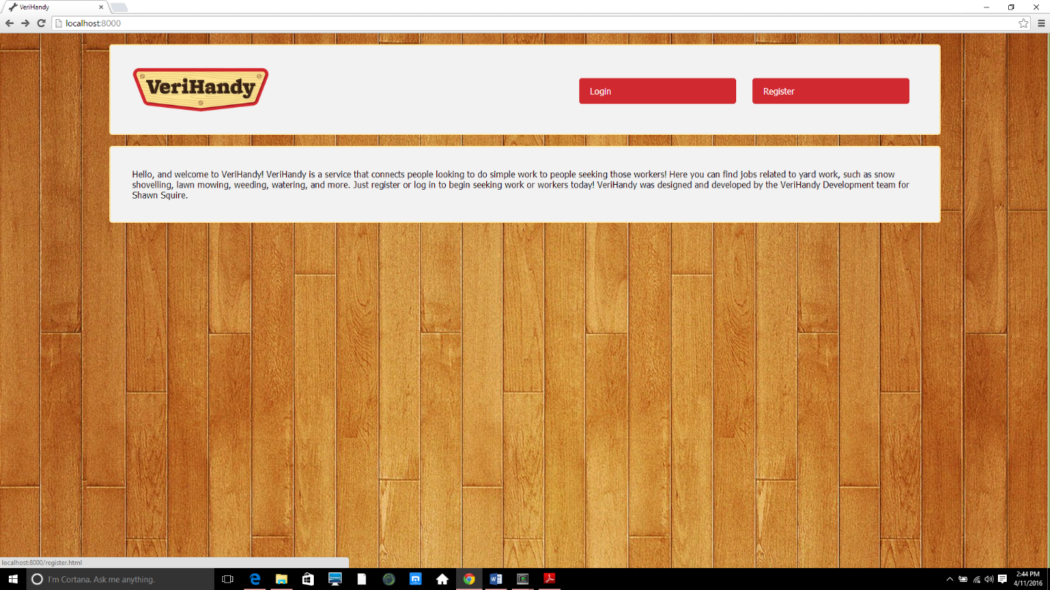

**Page displaying the registration credentials**

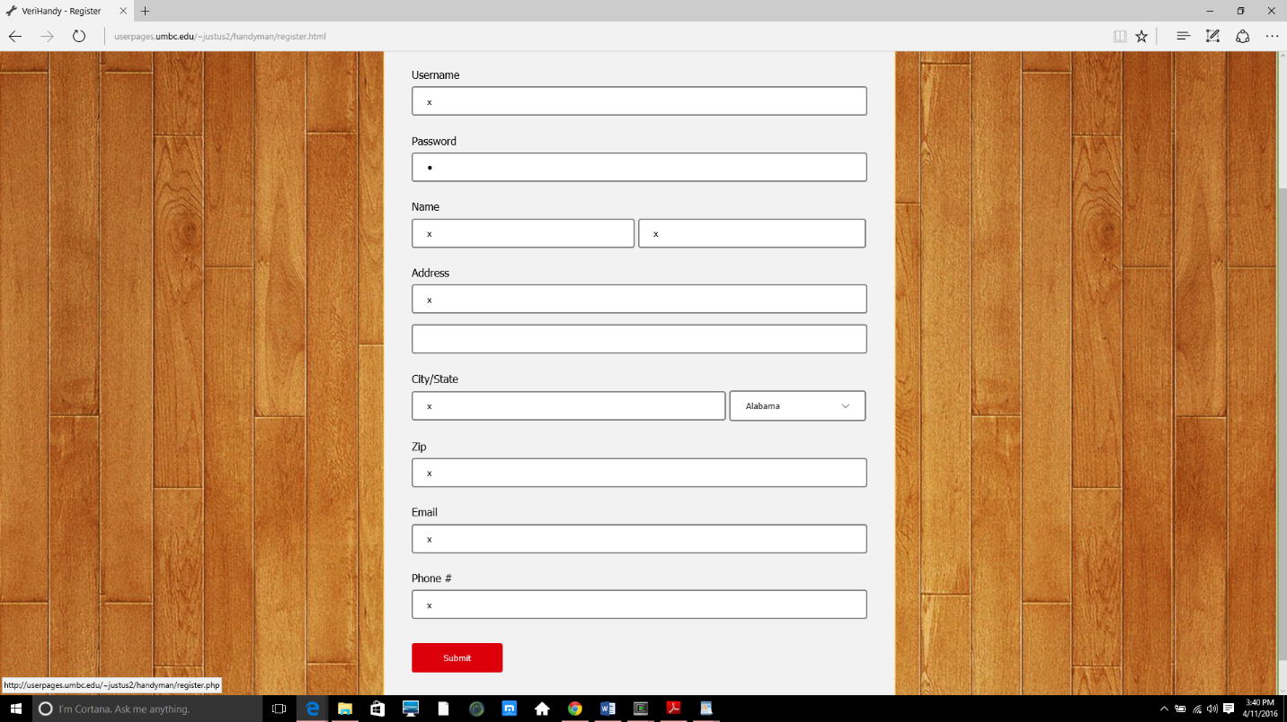

**Message displaying successful registration**

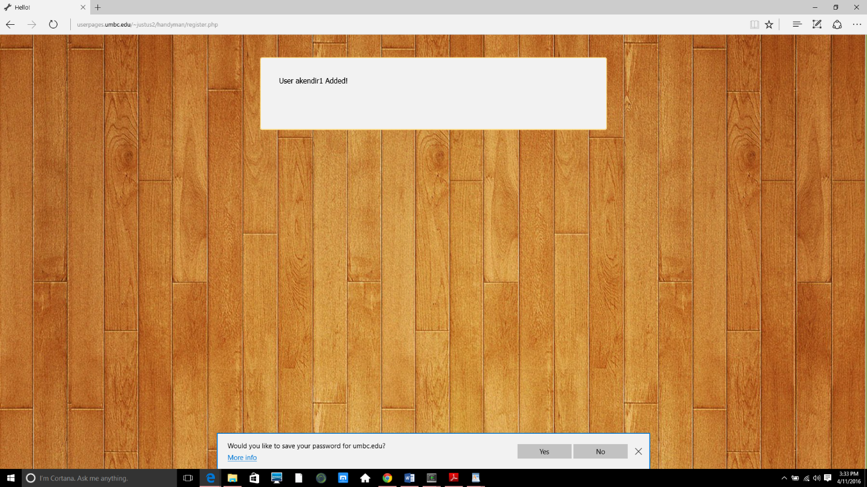

**Invalid situation:**

**Page shows null credential error checking**

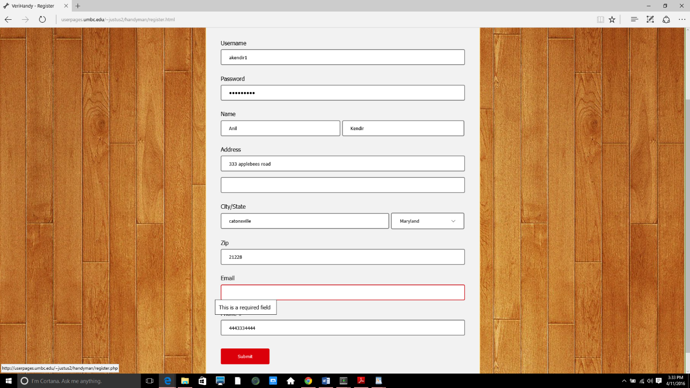

**3.2.2 Use Case Log In**

**Valid Situation:**

**Home page showing log in feature**

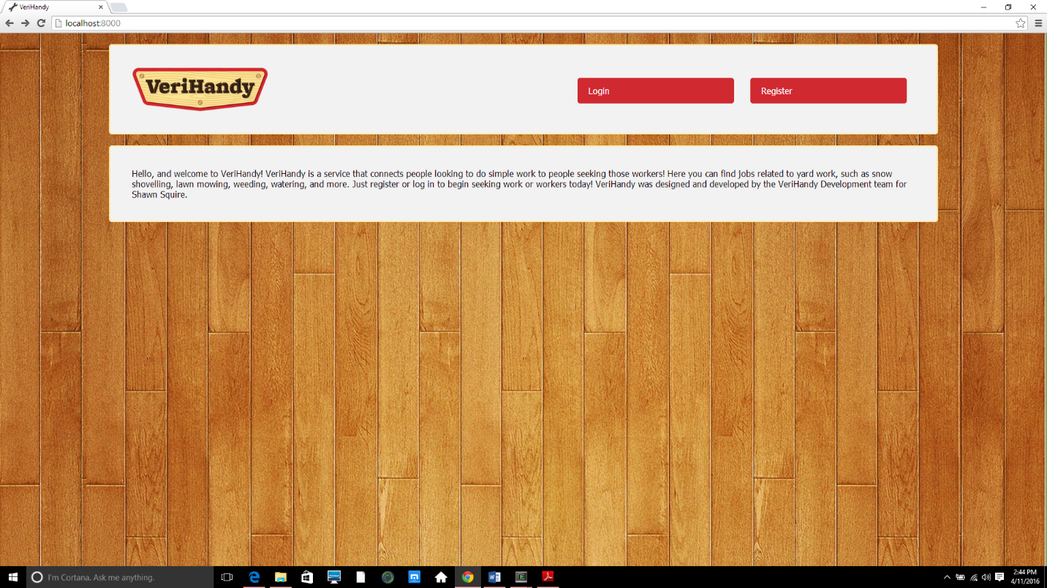

**Page displaying the log in credentials and confirmation button**

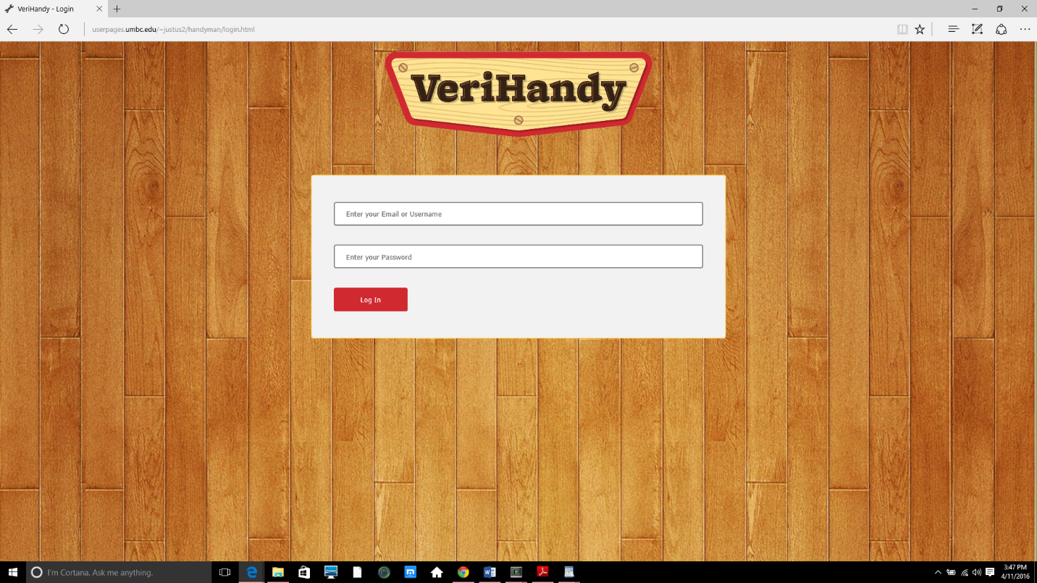

**User is prompted with a welcome message**

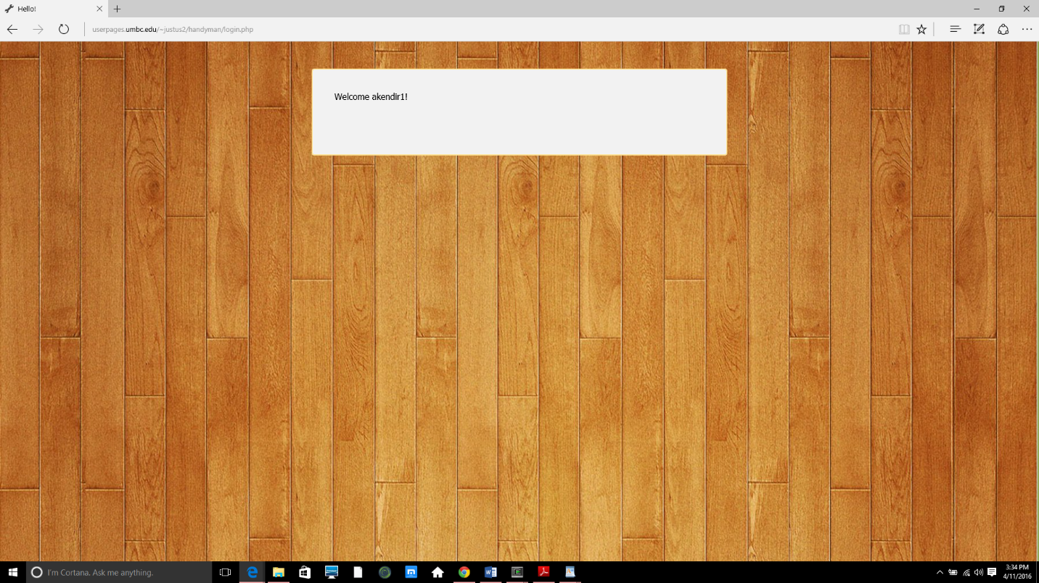

**Invalid Situation:**

**Null values for password or username**

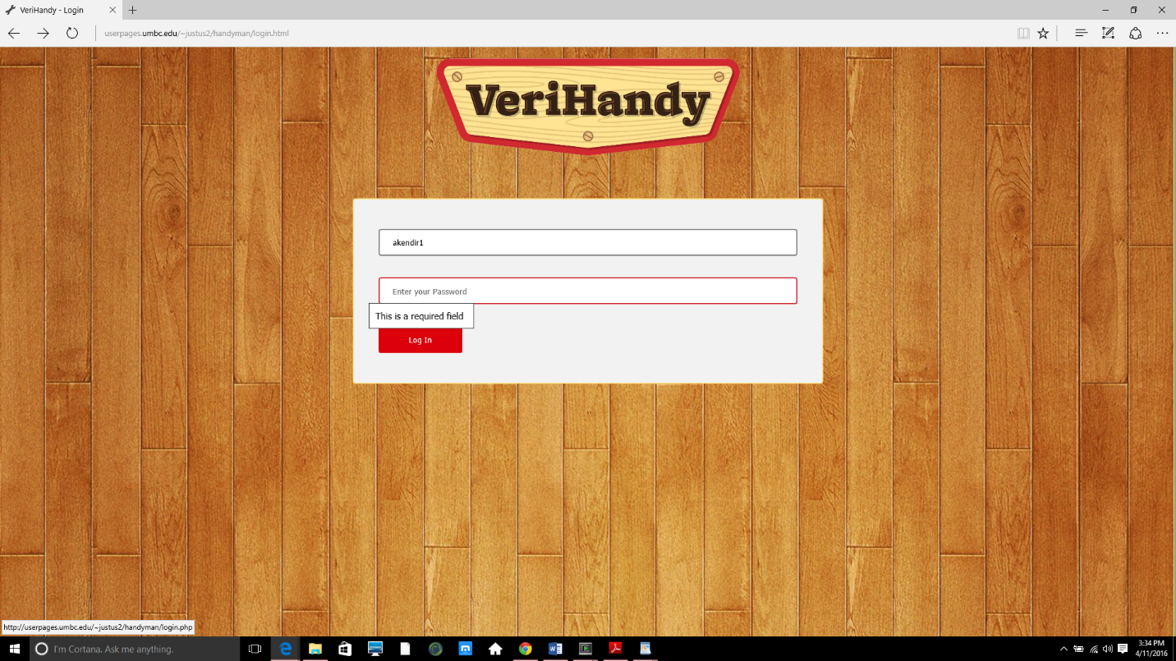

**Failed login attempt if given non existing or invalid credentials**

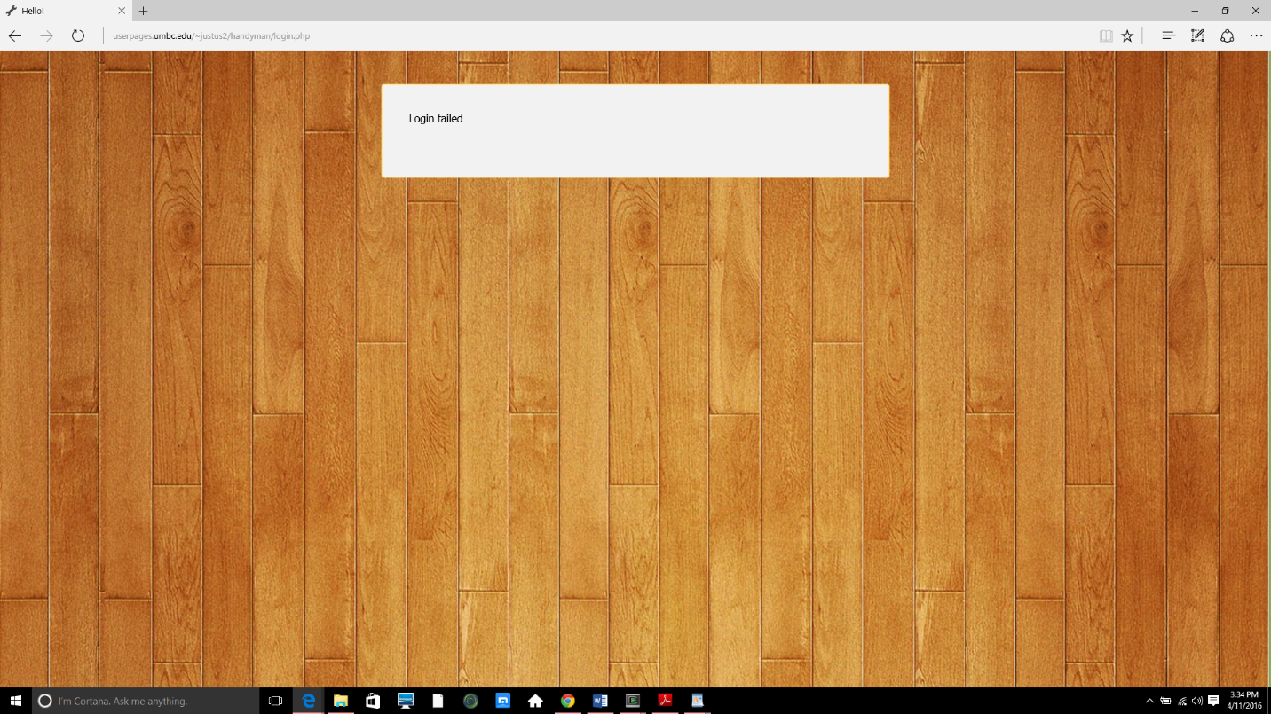

**3.2.3 Creating a job listing**

**Valid situation:**

* **User clicks on job creation and is redirected to the job creation page**

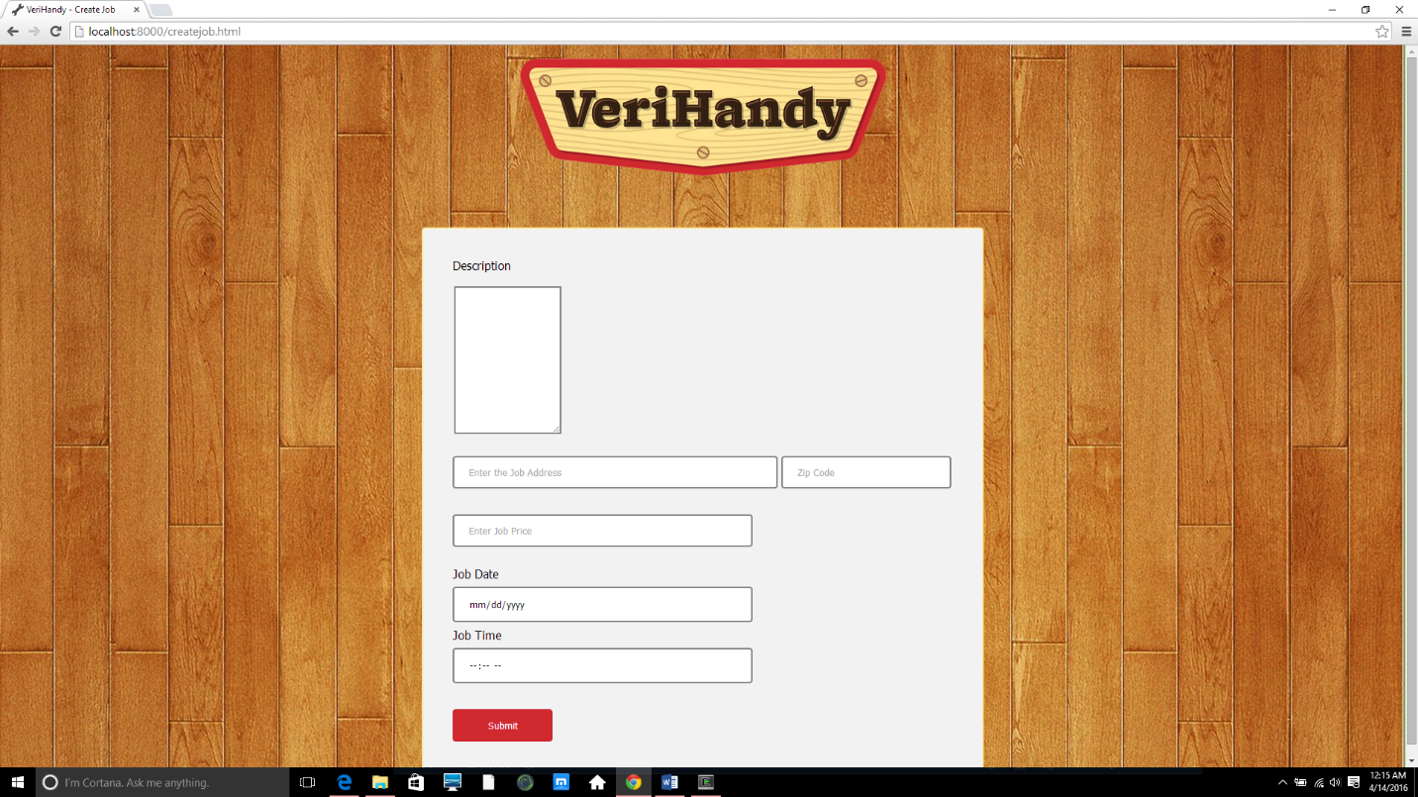

* **User enters valid job description in the given fields, and is shown a success message before being redirected**

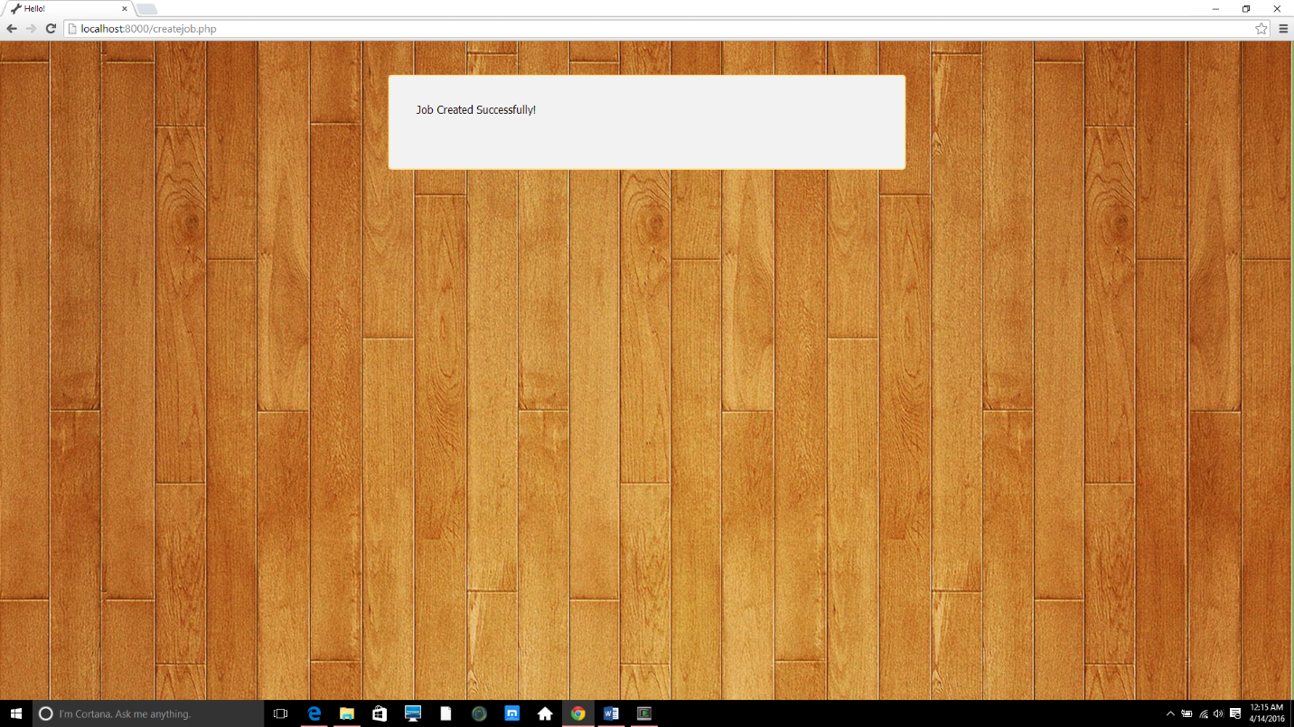

**Invalid situation:**

* **No major road blocks for not filling in the correct information, however the user is prompted for NULL values**

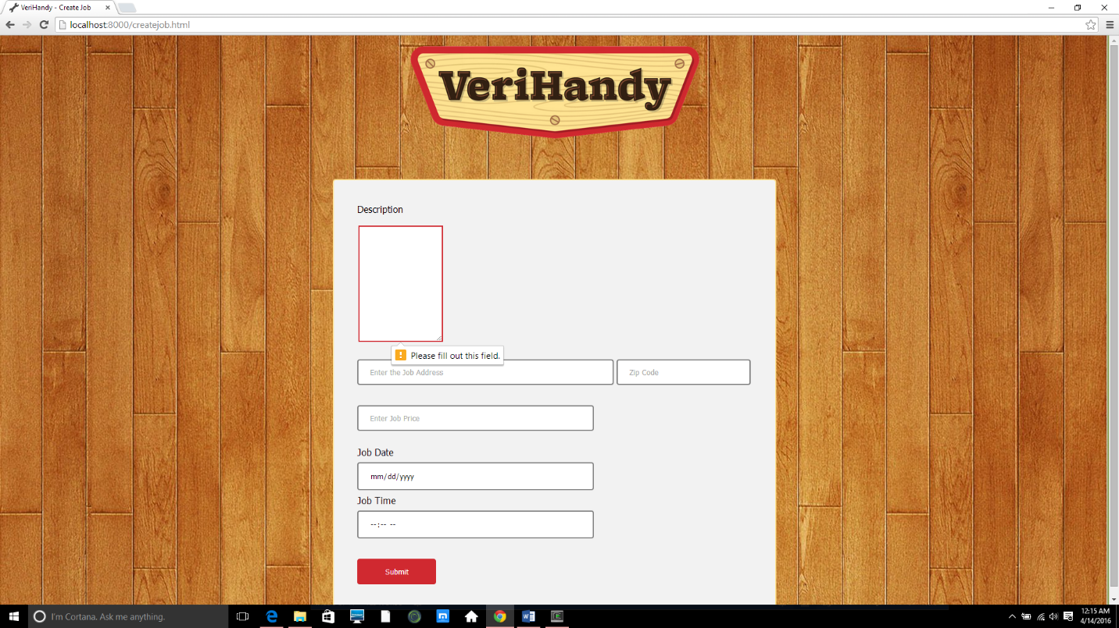

3.2.4 User Review

* Upon setting job completion, both users are redirected to a review submission page. Here, they will input the star rating and a comment regarding their transaction, although they are allowed to forgo the comment

Valid situation: The user enters a star rating between 1 and 5

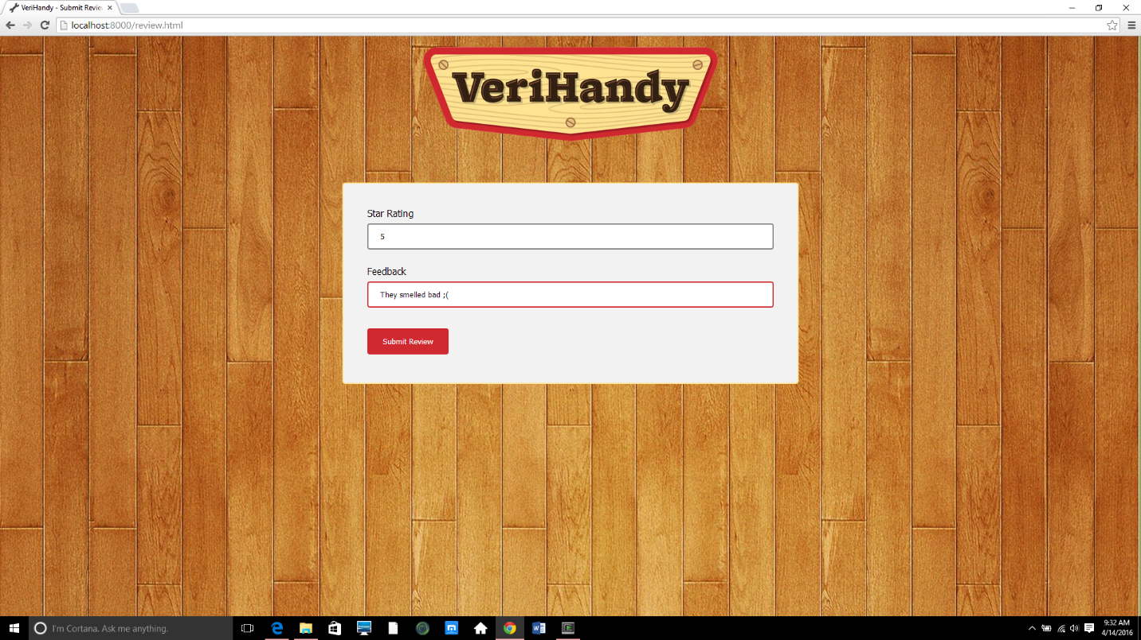

Invalid Situation: The user does not enter a star rating, or enters an invalid one and is prompted by the system

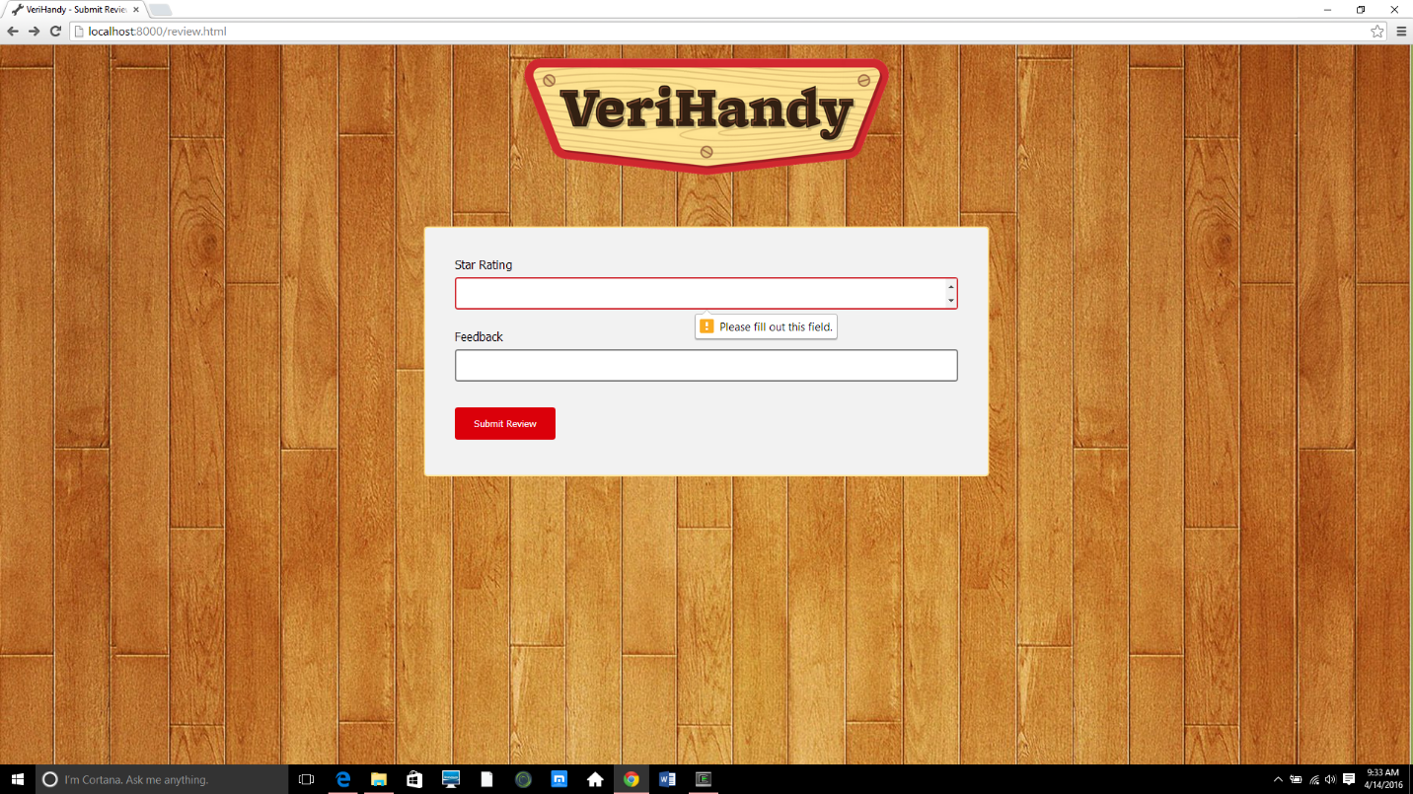

**Appendix A – Team Review Sign-off**

Signatures here indicate that all members of the team have reviewed and agreed upon the document’s content and format.

Team Comments:

---------------------------------------------------------------------------------------------------------------------

Signatures:

Shawn Squire: _____________________________________ Date: ___________________

Anil Kendir: _______________________________________ Date: ___________________

Matt Wheeler: _____________________________________ Date: ___________________

Justus Jackson: ______________________________________ Date: ___________________

Dean Fleming: ______________________________________ Date: ___________________

Tristan Adams: ______________________________________ Date: ___________________

**Appendix B – Document Contributions**

Anil Kendir

* Wrote Testing Process description
* Added sessions table
* Wrote test results breakdown
* Added Testing Suite and Testing Results for Use cases 1, 2
* Added Testing Suite and Testing Results for Use case 3
* Added Testing Suite and Testing Results for Use case 6

Matt Wheeler

* Wrote the Introduction section
* Brought in initial template for document

Justus Jackson

Dean Fleming

Tristan Adams